11. Spectrum Analysis of Sub-1 GHz, Mid-band, and mmWave by Plotting Propagation Loss at 700 MHz, 3.5 GHz, and 28 GHz

AIM:
To analyze and compare the path loss characteristics of three major 5G spectrum bands—700 MHz (Sub-1 GHz), 3.5 GHz (Mid-band), and 28 GHz (mmWave)—over distances up to 5 km using COST-231 Hata and Free-Space path loss models.

TOOLS REQUIRED:
- MATLAB
- Communications Toolbox
- Signal Processing Toolbox
- Laptop/PC

THEORY:

Wireless signal attenuation increases with distance and frequency.
- Sub-1 GHz (700 MHz) experiences lower path loss and supports long-range coverage.
- Mid-band (3.5 GHz) provides a balance between range and capacity.
- mmWave (28 GHz) suffers high path loss but enables extremely high data rates at short distances.
Propagation models used:
- COST-231 Hata model → applicable for Sub-6 GHz urban environments.
- Free Space Path Loss (FSPL) → used for mmWave bands with an added 2 dB atmospheric absorption loss.

PROCEDURE:

- Define operating bands: 700 MHz, 3.5 GHz, and 28 GHz.
- Set distance range from 10 m to 5 km.
- Calculate path loss for Sub-6 GHz bands using the COST-231 Hata model.
- Compute mmWave path loss using FSPL with atmospheric attenuation.
- Plot path loss vs distance for all three bands on a single graph.
- Label each curve for easy comparison.

CODE:

clear; clc; close all;

%% PARAMETERS
c = 3e8; % Speed of light (m/s)
d = 10:10:5000; % Distance in meters
freq = [0.7e9, 3.5e9, 28e9]; % Frequencies: 700 MHz, 3.5 GHz, 28 GHz
band_names = {'700 MHz (Sub-1 GHz)','3.5 GHz (Mid-band)','28 GHz (mmWave)'};

PL = zeros(length(freq), length(d));

%% BASE STATION & MOBILE HEIGHT
h_bs = 30; % Base station height (m)
h_ms = 1.5; % Mobile station height (m)

%% PATH LOSS CALCULATION
for i = 1:length(freq)
f_MHz = freq(i)/1e6;

if freq(i) <= 6e9 % Sub-6 GHz → COST-231 Hata
if f_MHz <= 200
a_hms = 8.29*(log10(1.54*h_ms))^2 - 1.1;
else
a_hms = 3.2*(log10(11.75*h_ms))^2 - 4.97;
end
PL(i,:) = 46.3 + 33.9*log10(f_MHz) - 13.82*log10(h_bs) - a_hms + ...
(44.9 - 6.55*log10(h_bs))*log10(d/1000);
else % mmWave → Free space path loss
lambda = c/freq(i);
PL(i,:) = 20*log10(4*pi*d/lambda) + 2; % FSPL + 2 dB atmospheric loss
end
end

%% PLOT
figure;
colors = {'b','r','g'};
hold on;
for i = 1:length(freq)
plot(d, PL(i,:), 'LineWidth', 2, 'Color', colors{i});

% Add text label near the end of the line
text(d(end-10), PL(i,end-10), band_names{i}, 'Color', colors{i}, 'FontWeight','bold');
end

grid on;
xlabel('Distance (m)');
ylabel('Path Loss (dB)');
title('Path Loss vs Distance for Different Frequency Bands');
OUTPUT:
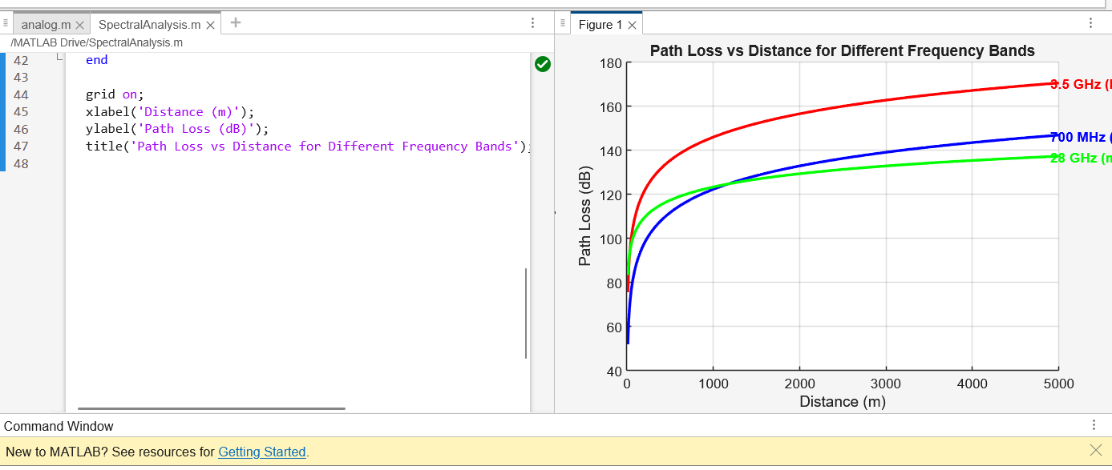
RESULT:
This experiment confirms that lower frequencies support long-distance communication with less path loss, while higher frequencies such as mmWave suffer significant propagation loss and require dense small-cell deployments. Thus, Sub-1 GHz, Mid-band, and mmWave bands each play a unique and complementary role in 5G communication networks.

